Consolidated Coverage Dossier: Jupiter Wagons Limited ends FY23 with highest ever Annual Revenue and PAT
Reports Industry leading EBITDA margin of 12.5% in FY23
FY23 PAT increases 151% to ₹ 12,538 lakh Board recommends Maiden Dividend

Date: 25 May 2023

COVERAGE SUMMARY
MEDIA | NO. OF CLIPS | PR VALUE (IN INR)
PRINT | 2 | 0.05 Million
ONLINE | 7 | 2.46 Million
ELECTRONIC | 2 | 0.09 Million
TOTAL | 10 | 2.6 Million

PRINT
Article  Date | Headline / Summary | Publication | Edition | Ad Value  (INR) | PR Value  (INR) | Readership
27 May, 2023 | Jupiter Wagons | Ei Samay | Kolkata | 16933 | 50799 | 263000
5th June, 2023 | Jupiter Wagons Ltd FY23 PAT Increases 151% to Rs 12,538 lakh | Echo of India | Kolkata | 100000 | 300000 | 217000
ONLINE
25 May, 2023 | Jupiter Wagons Consolidated March 2023 Net Sales at Rs 711.70 crore, up 96.27% Y-o-Y | Moneycontrol | Online | 140000 | 420000 | 1260000
26 May, 2023 | Jupiter Wagons Ltd Q4 FY2022-23 consolidated net profit slips QoQ to Rs. 39.21 crores | Equity Bulls | Online | 140000 | 420000 | 1260000
26 May, 2023 | Jupiter Wagons Ltd recommends dividend of Rs. 0.50 | Equity Bulls | Online | 140000 | 420000 | 1260000
26 May, 2023 | JUPITER WAGONS LIMITED ENDS FY23 WITH HIGHEST EVER ANNUAL REVENUE AND PAT | WhatsNewLife | Online | 80000 | 240000 | 720000
28 May, 2023 | Rs 5,818.36 crore order book: Multibagger railways wagon stock hits upper circuit and 52-week high on stellar results, declares dividend! | Dalal Street Investment Journal | Online | 140000 | 420000 | 1260000
29 May, 2023 | Jupiter Wagons Limited Q4 Result | Financial Samachar | Online | 80000 | 240000 | 720000
29 May, 2023 | Jupiter Wagons Hits 52-week high on Stellar Q4FY23 and FY23 Results; Declares Dividend! | Angel One | Online | 100000 | 300000 | 900000
ELECTRONIC
26 May, 2023 | ET Now Swadesh Results Now 26 May 2023 04min 24sec Mr. Vivek Lohia - MD, Jupiter Wagons 10.50am | ET Now Swadesh | National | 10824 | 32472 | 1229640
26 May, 2023 | Varinder Results X-RAY: Analyzing Globus Spirits, ITD Cementation & Jupiter Wagons Q4 Results! Z | Zee Business | National | 20956 | 62868 | 11462350

PRINT

Date | Publication | Edition | Page no. | Journalist
27-05-23 | Ei Samay | Kolkata | 4 | Ei Samay

ONLINE

Date | Publication | Edition | Journalist
27-05-23 | Moneycontrol | Online | Bureau

Jupiter Wagons Consolidated March 2023 Net Sales at Rs 711.70 crore, up 96.27% Y-o-Y
MAY 25, 2023 / 11:09 PM IST
Reported Consolidated quarterly numbers for Jupiter Wagons are:
Net Sales at Rs 711.70 crore in March 2023 up 96.27% from Rs. 362.61 crore in March 2022.
Quarterly Net Profit at Rs. 39.21 crore in March 2023 up 184.18% from Rs. 13.80 crore in March 2022.
EBITDA stands at Rs. 93.23 crore in March 2023 up 188.91% from Rs. 32.27 crore in March 2022.
Jupiter Wagons EPS has increased to Rs. 1.01 in March 2023 from Rs. 0.36 in March 2022.
Jupiter Wagons shares closed at 122.20 on May 24, 2023 (NSE) and has given 53.23% returns over the last 6 months and 118.02% over the last 12 months.

Date | Publication | Edition | Journalist
26-05-23 | Equity Bulls | Online | Bureau

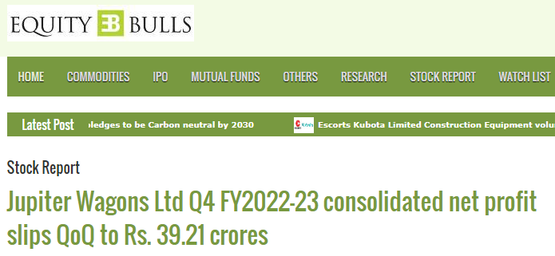
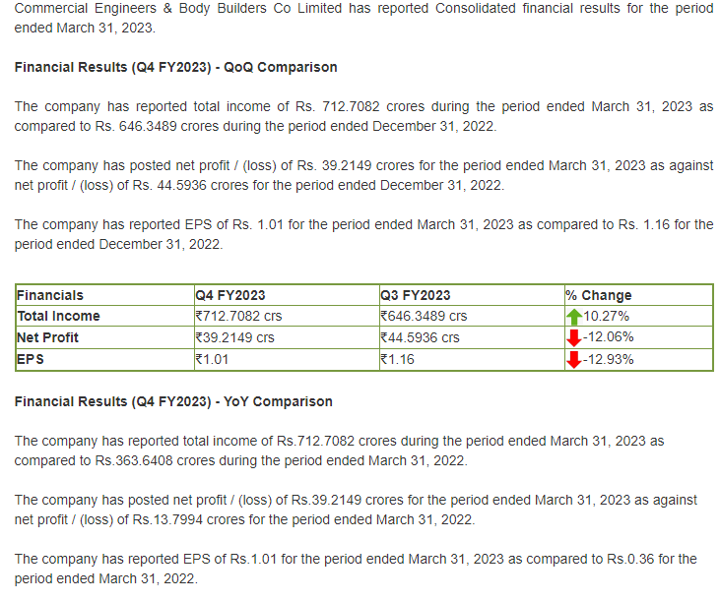

Date | Publication | Edition | Journalist
26-05-23 | Equity Bulls | Online | Bureau

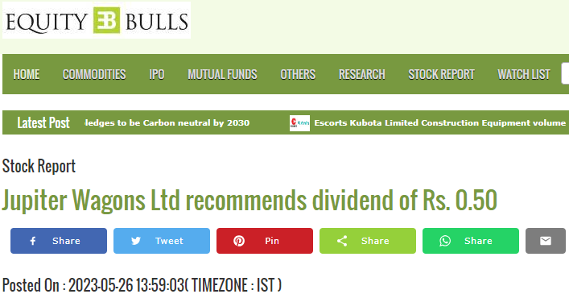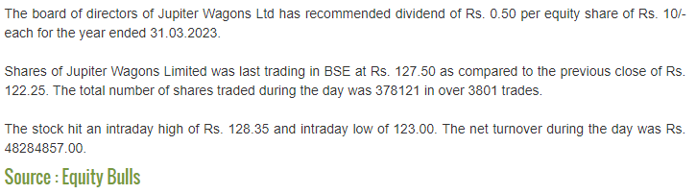

Date | Publication | Edition | Journalist
26-05-23 | WhatsNewLife | Online | WNL News Desk

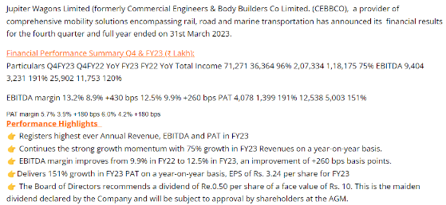
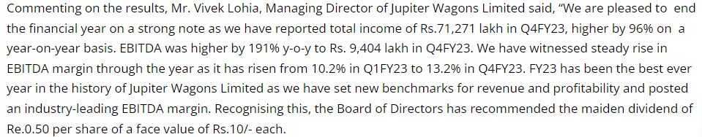

Date | Publication | Edition | Journalist
26-05-23 | Dalal Street Investment Journal | Online | Kiran Shroff

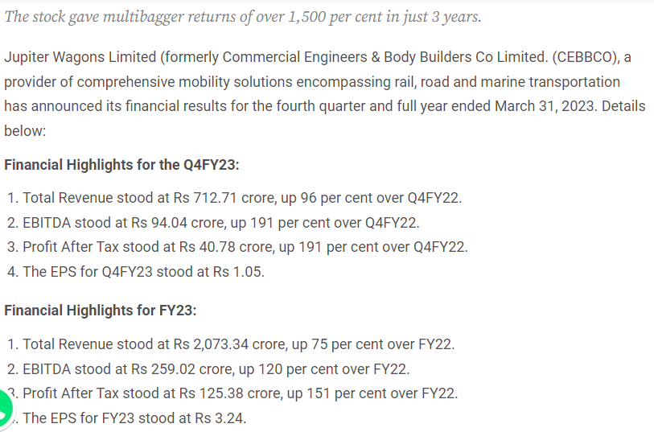

Date | Publication | Edition | Journalist
26-05-23 | Financial Samachar | Online | Financial Samachar Desk

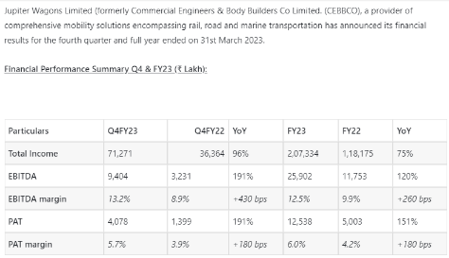

Date | Publication | Edition | Journalist
26-05-23 | Angel One | Online | Bureau

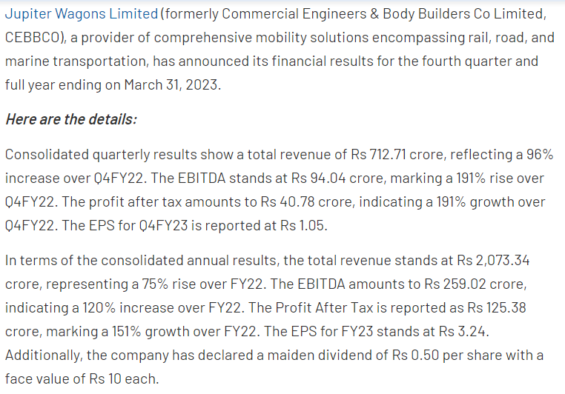

ELECTRONIC

Date | Publication | Edition
26-05-23 | ET Now Swadesh | National

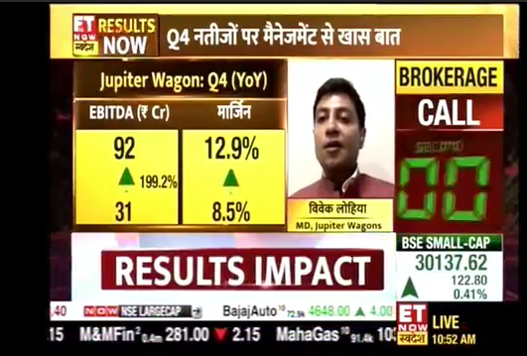

Date | Publication | Edition
26-05-23 | Zee Business | National

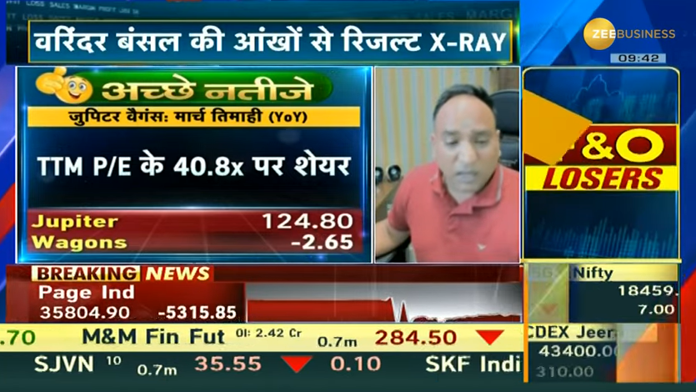

THANK YOU

