Consolidated Coverage Dossier: Jupiter Wagons Limited Raises ~Rs. 125 crores Through Qualified Institutional Placement

Date: 16 May, 2023

COVERAGE SUMMARY
MEDIA | NO. OF CLIPS | PR VALUE (IN INR)
PRINT | 13 | 2.11 Million
ONLINE | 27 | 8.7 Million
ELECTRONIC | 2 | 0.49 Million
Total: | 42 | 11.3 Million

PRINT
Article  Date | Headline / Summary |  | Publication |  |  | Edition | Ad Value  (INR) |  | PR Value  (INR) |  | Readership
17-05-23 | Jupiter Wagons raises Rs 125 cr via QIPs |  | The Times of India |  |  | Kolkata | 121497 |  | 364491 |  | 488814
17-05-23 | Jupiter Wagons raises Rs 125 crore via QIP route |  | The Hindu Business Line |  |  | Mumbai, New Delhi, Chennai, Hyderabad, Bangalore, Kolkata | 230590 |  | 691770 |  | 588183
17-05-23 | Mobility solutions firm Jupiter Wagons raises Rs 125 cr. via QIP |  | The Hindu |  |  | New Delhi, Chennai, Mumbai, Bangalore, Kolakata | 292963 |  | 878889 |  | 2637384
17-05-23 | Jupiter Wagons raises Rs 125 crore via QIP route |  | The Telegraph |  |  | Kolkata | 59904 |  | 179719 |  | 87000
ONLINE
Date | Article/ Headline |  | Publication |  |  | Edition | Ad Value (In INR) |  | PR Value  (In INR) |  | Impressions
16-05-23 | Jupiter Wagons to reopen Stone India in six months, ramp up wagon capacity |  | PTI |  |  | Online | 140000 |  | 420000 |  | 840000
16-05-23 | Jupiter Wagons to reopen Stone India in six months, ramp up wagon capacity |  | The Print |  |  | Online | 140000 |  | 420000 |  | 840000
16-05-23 | Jupiter Wagons to reopen Stone India in six months, ramp up wagon capacity |  | CNBC TV 18 |  |  | Online | 140000 |  | 420000 |  | 840000
16-05-23 | Jupiter Wagons raises ₹125 crore through QIP route |  | The Hindu Business Line |  |  | Online | 140000 |  | 420000 |  | 840000
16-05-23 | Jupiter Wagons raises Rs 125 cr via qualified institutional placement route |  | Business Standard |  |  | Online | 140000 |  | 420000 |  | 840000
16-05-23 | Jupiter Wagons raises ₹125 crore through QIP |  | The Hindu |  |  | Online | 140000 |  | 420000 |  | 840000
16-05-23 | Jupiter Wagons to reopen Stone India in six months ramp up wagon capacity |  | The Week |  |  | Online | 140000 |  | 420000 |  | 840000
16-05-23 | Jupiter Wagons to Reopen Stone India in Six Months, Ramp Up Wagon Capacity |  | Latest LY |  |  | Online | 100000 |  | 300000 |  | 600000
16-05-23 | Jupiter Wagons raises Rs 125 cr via QIP |  | Devdiscourse |  |  | Online | 100000 |  | 300000 |  | 600000
16-05-23 | Jupiter Wagons boosts finances with Rs 125 cr from QIP |  | Construction Week |  |  | Online | 140000 |  | 420000 |  | 840000
16-05-23 | Jupiter Wagons Limited’s Qualified Institutional Placement receives an overwhelming response |  | Manufacturing Today |  |  | Online | 140000 |  | 420000 |  | 840000
16-05-23 | Jupiter Wagons Raises INR1.25 Billion Via Placement |  | Market Screener |  |  | Online | 100000 |  | 300000 |  | 600000
16-05-23 | Jupiter Wagons Limited raises ~Rs. 125 crores through Qualified Institutional Placement |  | Equity Bulls |  |  | Online | 140000 |  | 420000 |  | 840000
16-05-23 | Jupiter Wagons Raises ₹125 Crore Through QIP |  | Quick Telecast |  |  | Online | 80000 |  | 240000 |  | 840000
16-05-23 | Jupiter Wagons raises Rs 125 cr via qualified institutional placement route |  | News on News |  |  | Online | 80000 |  | 240000 |  | 840000
16-05-23 | Jupiter Wagons Raises ₹125 Crore Through QIP |  | Journey Line |  |  | Online | 100000 |  | 300000 |  | 600000
16-05-23 | Jupiter Wagons raises Rs 125 cr via qualified institutional placement route |  | The Spuzz |  |  | Online | 80000 |  | 240000 |  | 480000
16-05-23 | Jupiter Wagons raises Rs 125 cr via qualified institutional placement route |  | Topology Pro |  |  | Online | 80000 |  | 240000 |  | 480000
16-05-23 | Jupiter Wagons gains on raising Rs 125 Cr via QIP |  | Capital Market |  |  | Online | 80000 |  | 240000 |  | 480000
16-05-23 | Jupiter Wagons Limited Raises Rs. 125 crores Through Qualified Institutional Placement |  | Biz Next |  |  | Online | 80000 |  | 240000 |  | 480000
16-05-23 | Jupiter Wagons shines on raising Rs 125 crore through QIP |  | Investment Guru India.com |  |  | Online | 80000 |  | 240000 |  | 480000
16-05-23 | Shares of this small-cap railway company surged by more than 3 per cent on raising Rs 125 crore |  | Dalal Street Investment Journal |  |  | Online | 80000 |  | 240000 |  | 480000
16-05-23 | Jupiter Wagons shines on raising Rs 125 crore through QIP |  | Money Works 4 Me |  |  | Online | 80000 |  | 240000 |  | 480000
16-05-23 | Jupiter Wagons Raises Rs. 125 cr via QIP |  | News Drum |  |  | Online | 80000 |  | 240000 |  | 480000
`16-05-23 | Jupiter Wagons raises Rs 125 cr via qualified institutional placement route |  | BeamStart |  |  | Online | 80000 |  | 240000 |  | 480000
17-05-23 | Jupiter Wagons to reopen Stone India in six months |  | ET Infra |  |  | Online | 140000 |  | 420000 |  | 840000
ELECTRONIC
Date |  | Headline |  | Publication | Edition |  |  | Ad Value |  | PR Value |  | Viewership
16-05-23 |  | Zee Business Power Breakfast 16 May 2023 15sec Jupiter Wagons |  | Zee Business | National |  |  | 137924 |  | 413772 |  | 827544
16-05-23 |  | ET Now Swadesh Trimurti Shares 16 May 2023 57sec Jupiter Wagons Raise Rs. 125cr Funds Via Institutional Placement 08.30am |  | ET Now Swadesh | National |  |  | 27900 |  | 83700 |  | 45685590

PRINT

Date | Publication | Edition | Page no. | Journalist
17-05-23 | The Times of India | Kolkata | 17 | Times News Network

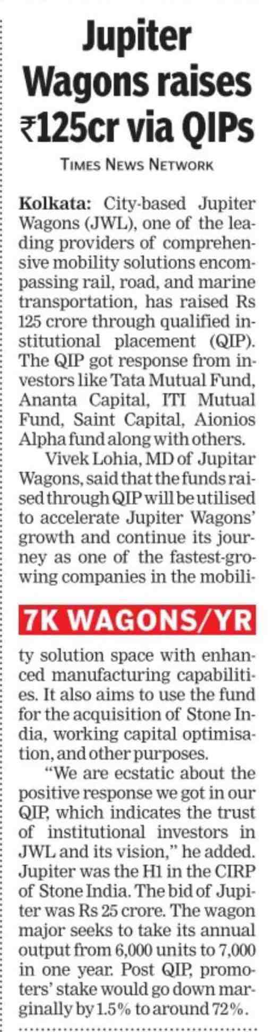

Date | Publication | Edition | Page no. | Journalist
17-05-23 | The Hindu Business Line | Mumbai, Chennai, New Delhi, Hyderabad, Kolkata, Bangalore | 6 | Bureau

Date | Publication | Edition | Page no. | Journalist
17-05-23 | The Hindu | New Delhi, Bangalore, Mumbai, Chennai, Kolkata | 16 | Bureau

Date | Publication | Edition | Page no. | Journalist
17-05-23 | The Telegraph | Kolkata | 6 | Bureau

ONLINE

Date | Publication | Edition | Journalist
16-05-23 | Press Trust of India | Online | Bureau

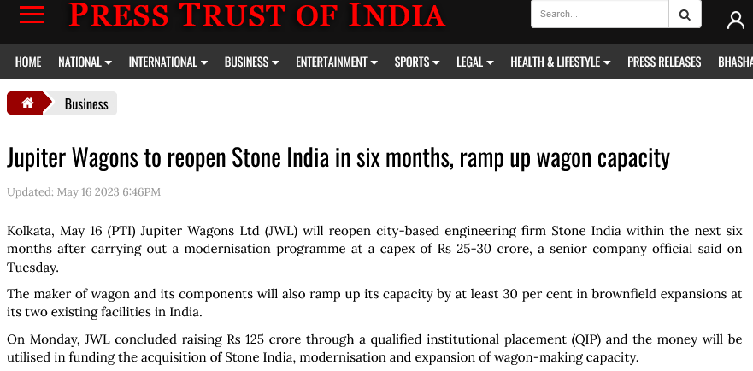

Date | Publication | Edition | Journalist
16-05-23 | The Print | Online | PTI

Date | Publication | Edition | Journalist
16-05-23 | CNBC TV | Online | PTI

Date | Publication | Edition | Journalist
16-05-23 | The Hindu Business Line | Online | BL Bureau

Date | Publication | Edition | Journalist
16-05-23 | Business Standard | Online | PTI

Date | Publication | Edition | Journalist
16-05-23 | The Hindu | Online | The Hindu Bureau

Date | Publication | Edition | Journalist
16-05-23 | The Week | Online | PTI

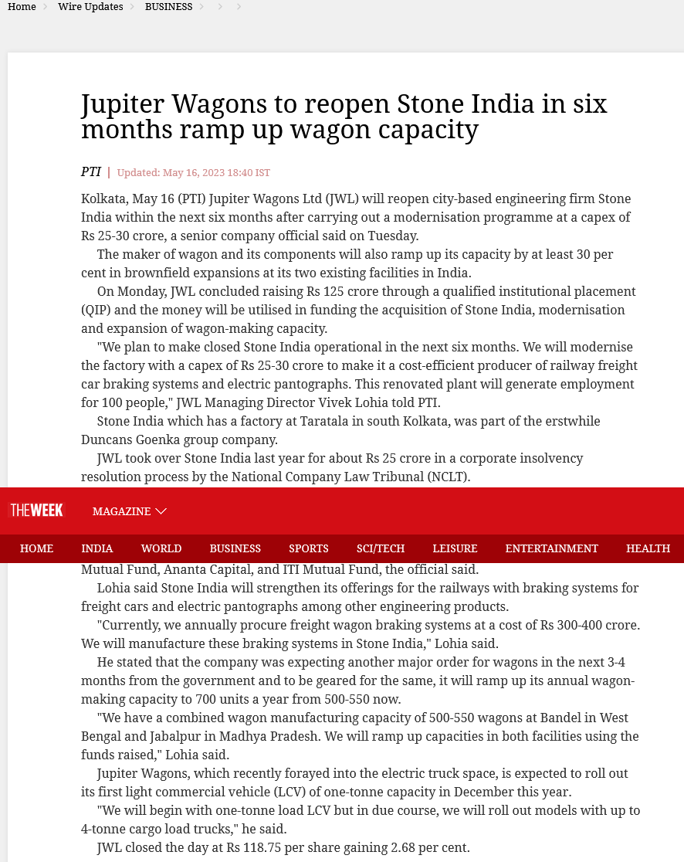

Date | Publication | Edition | Journalist
16-05-23 | The Latest LY | Online | PTI

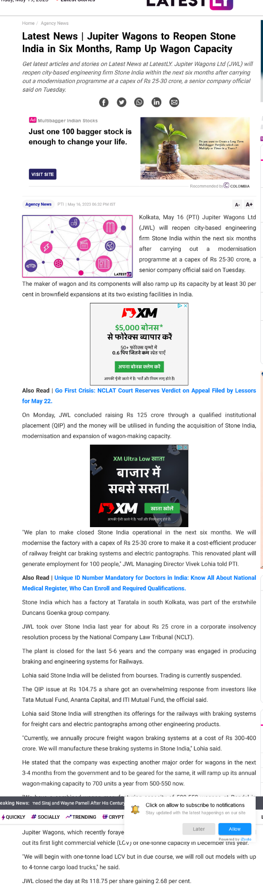

Date | Publication | Edition | Journalist
16-05-23 | Devdiscourse | Online | PTI

Date | Publication | Edition | Journalist
16-05-23 | Construction Week | Online | Staff Writer

Date | Publication | Edition | Journalist
16-05-23 | Manufacturing Today | Online | Staff Writer

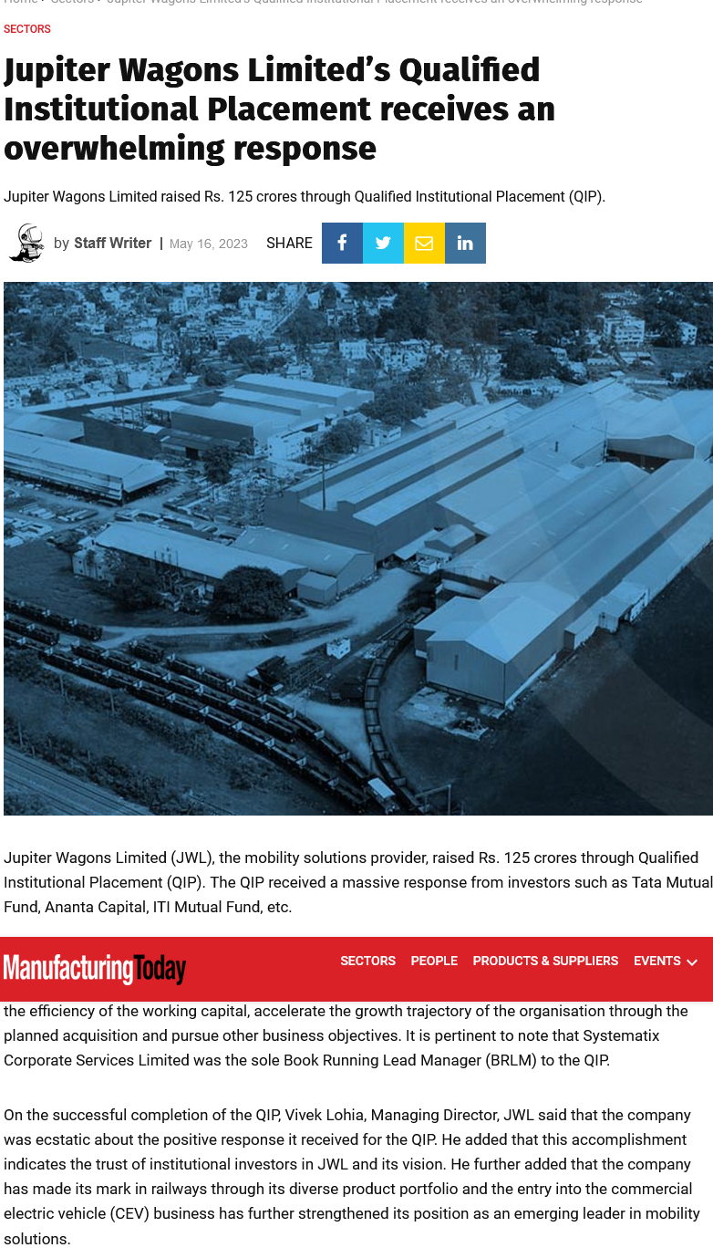

Date | Publication | Edition | Journalist
16-05-23 | Market Screener | Online | Staff Writer

Date | Publication | Edition | Journalist
16-05-23 | Equity Bulls | Online | Bureau

Date | Publication | Edition | Journalist
16-05-23 | AP Direct | Online | The Hindu Bureau

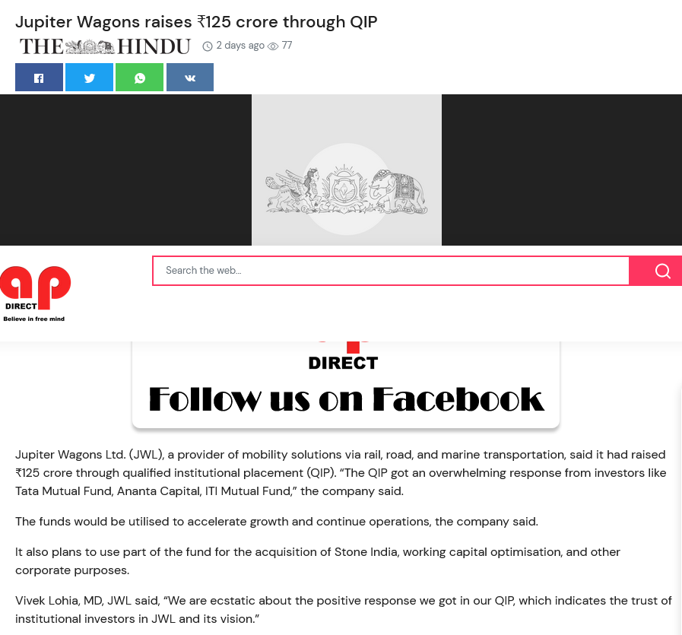

Date | Publication | Edition | Journalist
16-05-23 | Quick Telecast | Online | Samuel

Date | Publication | Edition | Journalist
16-05-23 | New on News | Online | Team New on News

Date | Publication | Edition | Journalist
16-05-23 | Journey Line | Online

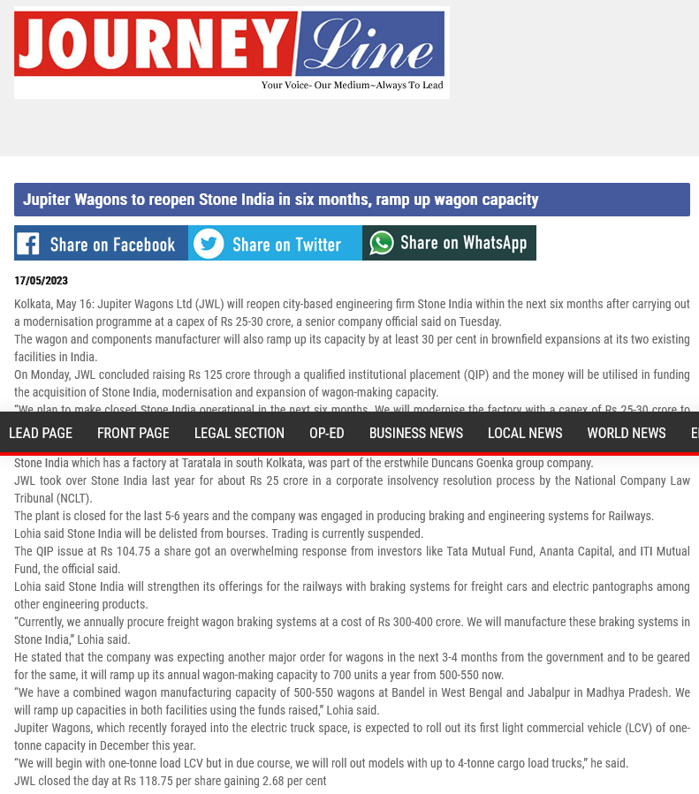

Date | Publication | Edition | Journalist
16-05-23 | The Spuzz | Online | The Spuzz Desk

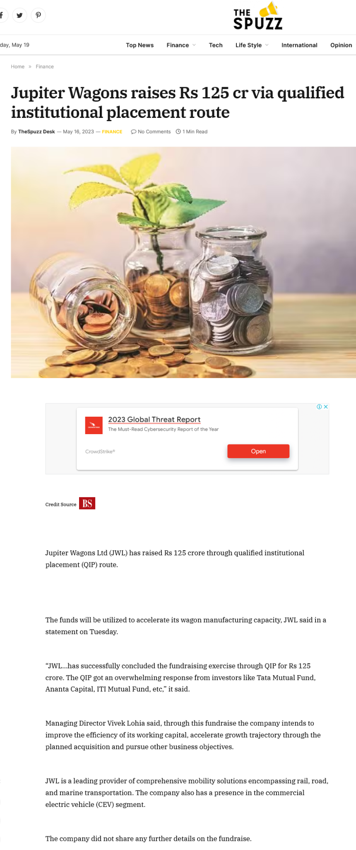

Date | Publication | Edition | Journalist
16-05-23 | Topology Pro | Online | The Spuzz Desk

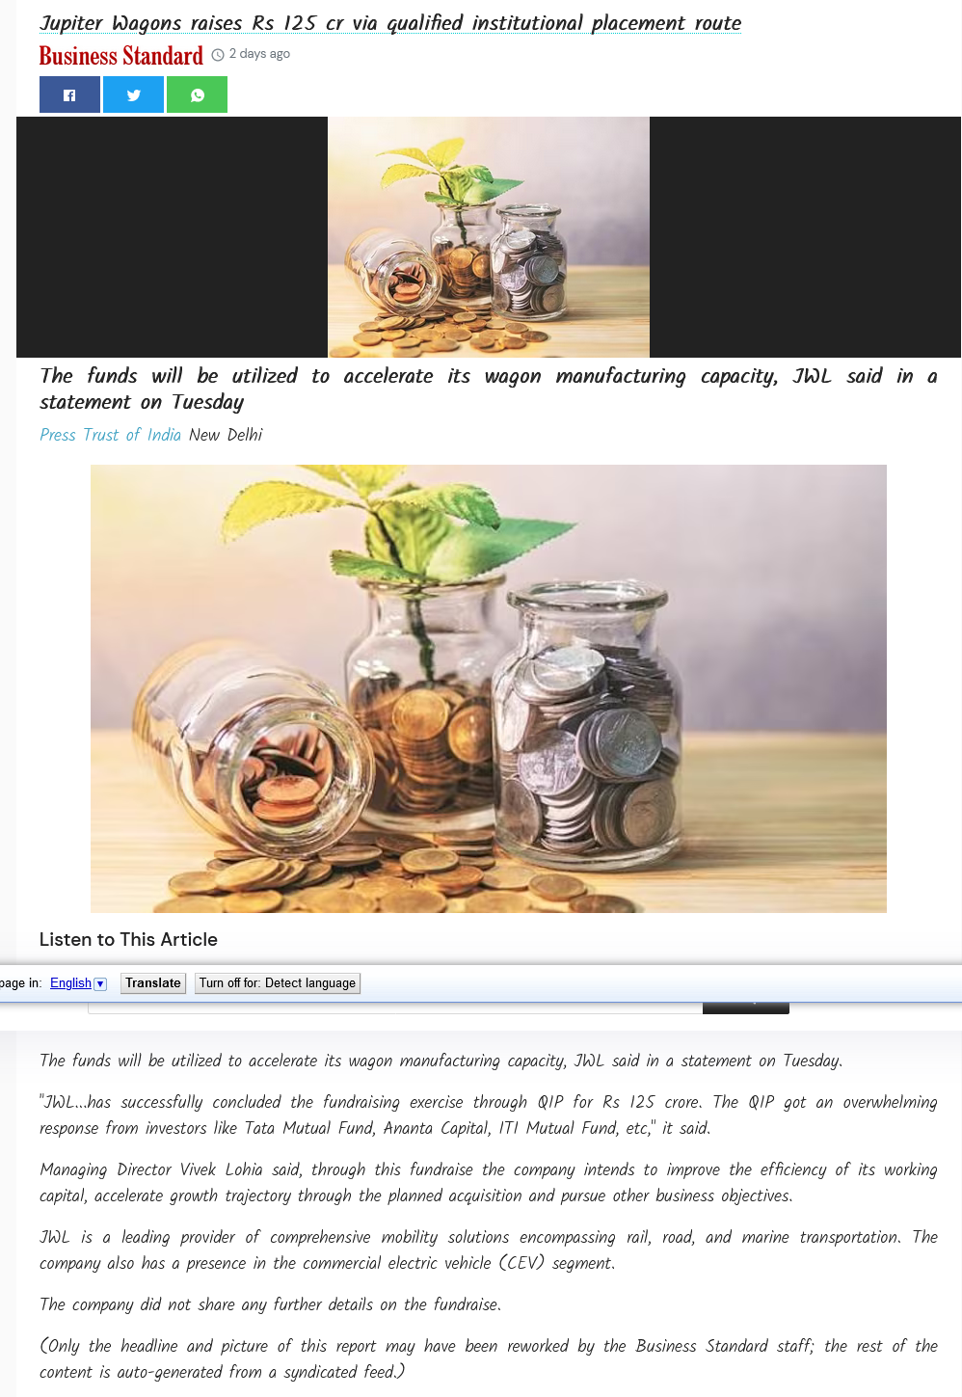

Date | Publication | Edition | Journalist
16-05-23 | Capital Market | Online | Capital Market.com

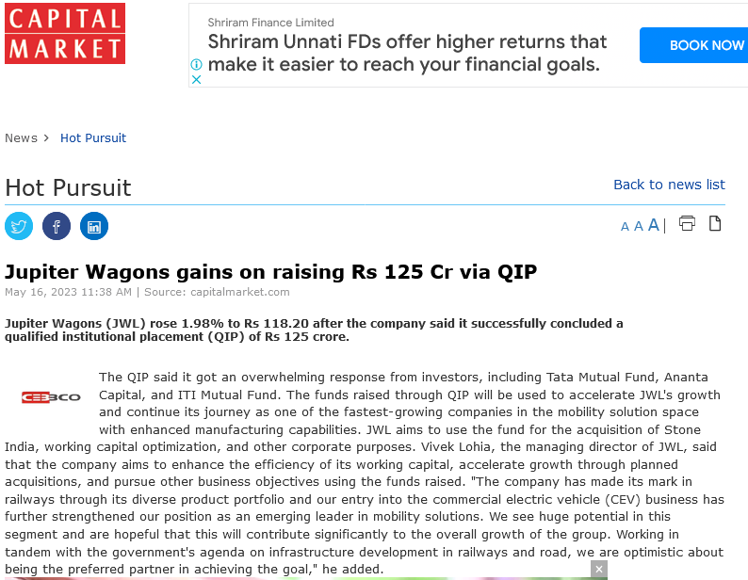

Date | Publication | Edition | Journalist
16-05-23 | Biz Next | Online | Admin

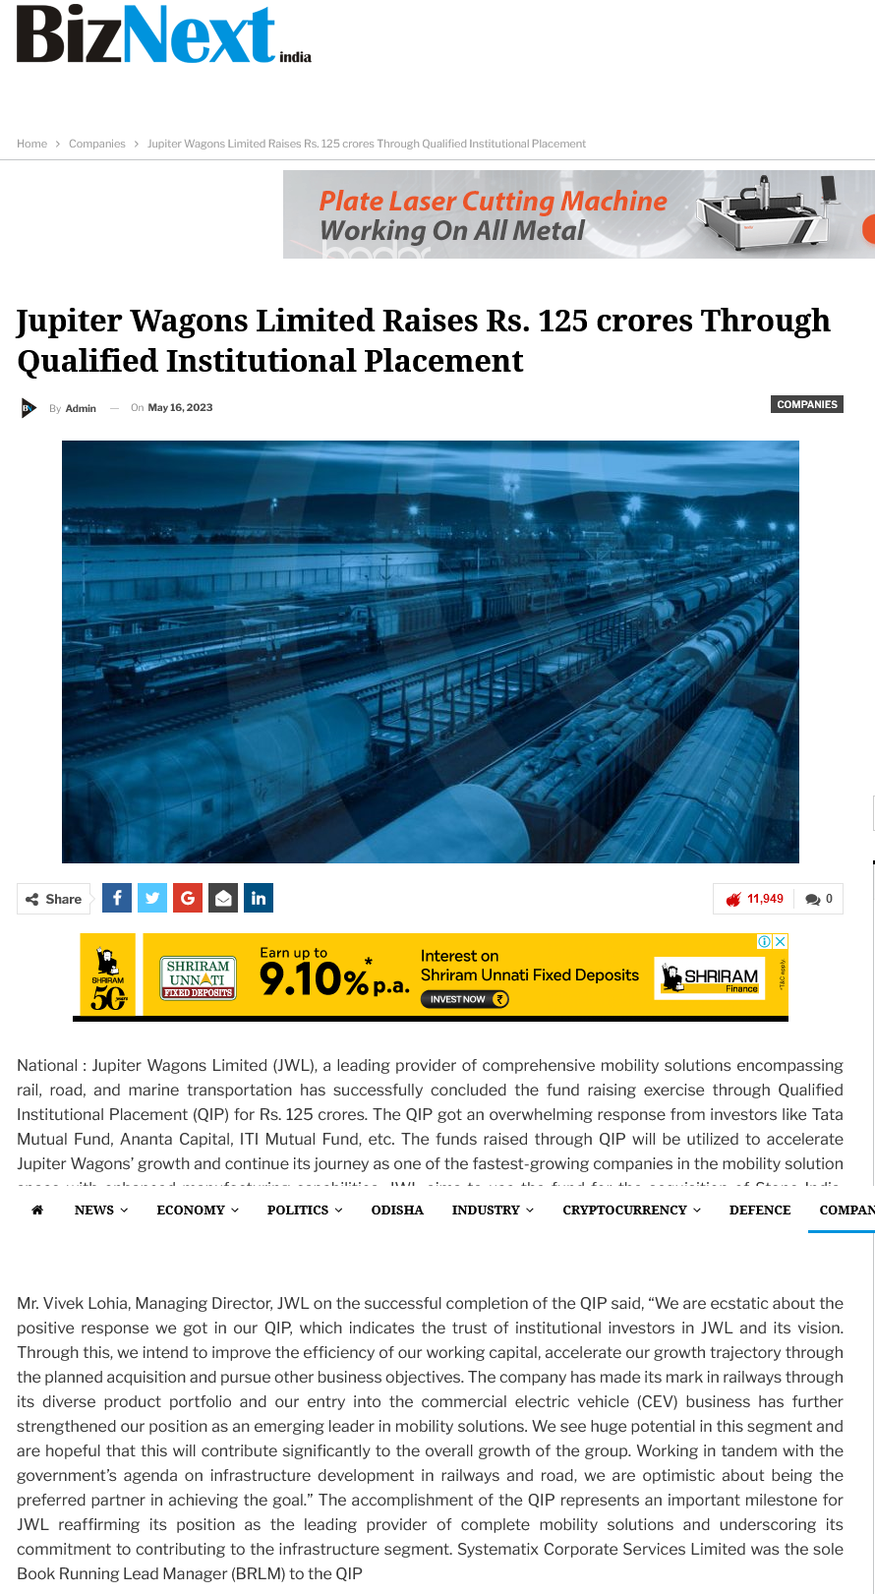

Date | Publication | Edition | Journalist
16-05-23 | Investment Guru | Online | Accord Fintech

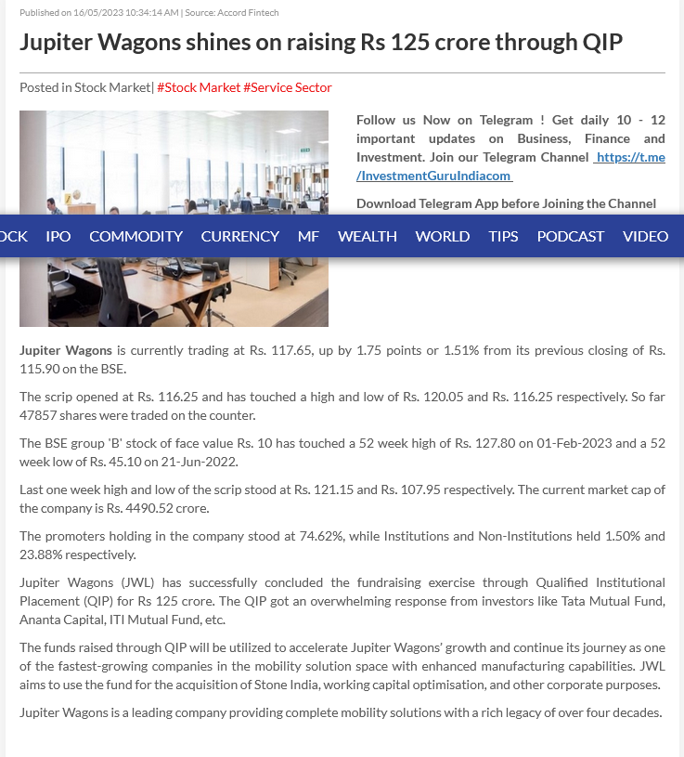

Date | Publication | Edition | Journalist
16-05-23 | Dalal Street Investment Journal | Online | Gyanesh Patodiya

Date | Publication | Edition | Journalist
16-05-23 | Money Works 4 Me | Online

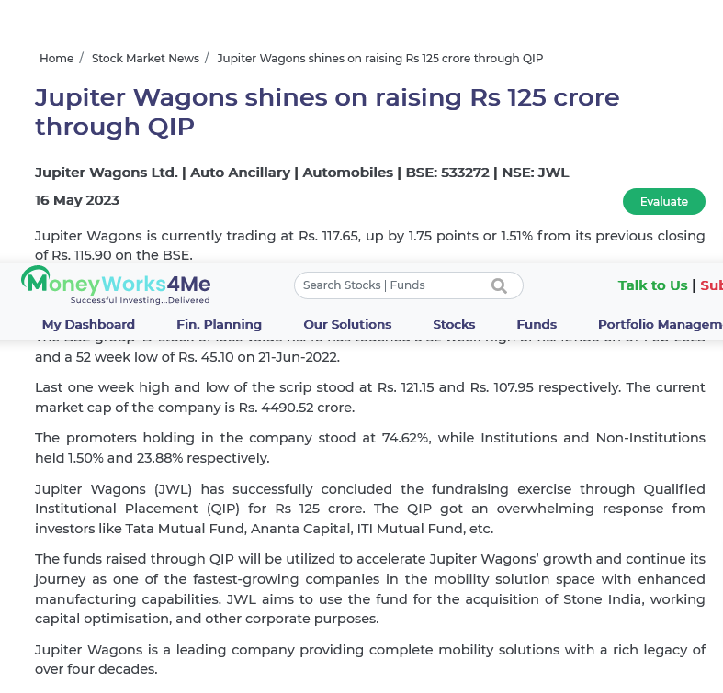

Date | Publication | Edition | Journalist
16-05-23 | News Drum | Online | News Drum Desk

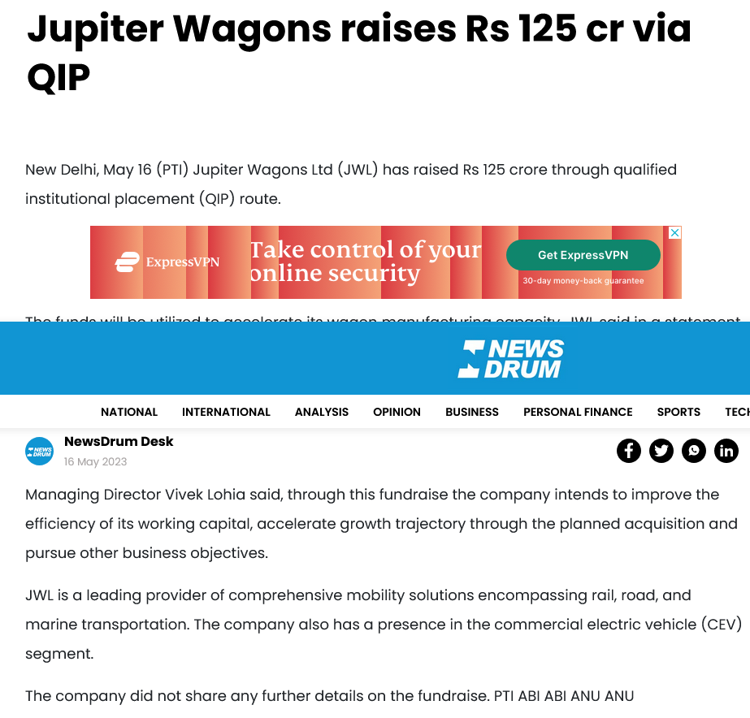

Date | Publication | Edition | Journalist
16-05-23 | Beam Start | Online | PTI

Date | Publication | Edition | Journalist
16-05-23 | ET Infra | Online | PTI

ELECTRONIC

Publication Date | Publication | Edition
16-05-23 | Zee Business | National

Publication Date | Publication | Edition
16-05-23 | ET Now Swadesh | National

THANK YOU

